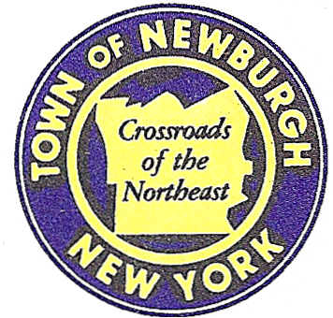

TOWN OF NEWBURGH
_______Crossroads of the Northeast __________________________
OLD TOWN HALL
308 GARDNERTOWN ROAD NEWBURGH, NEW YORK 12550

PLANNING BOARD
JOHN P. EWASUTYN, CHAIRMAN
TELEPHONE 845-564-7804
FAX 845-564-7802
E-MAIL: planningboard@townofnewburgh.org

PLANNING BOARD AGENDA

June 16th, 2016

*PLEASE NOTE: The Planning Board Meeting will start at 7:00 P.M. and all Applicants/Representatives
are to be present at that time. The Meeting will be held in the Meeting Room of Town Hall,
located at 1496 Route 300, Newburgh NY.*

1. Sarvis, LLC (2016-09) LOT LINE CHANGE
1 Balmville Rd & 2 Stern Dr.
Section 84, Block 5, Lot 34 & 33
Zone R-3
Rep: Talcott Engineering Design, PLLC.
1 Gardnertown Rd.
Newburgh, NY 12550

2. Lands of Mann (2015-09) 2 LOT SUBDIVISION
East Road
Section 2, Block 2, Lot 22.1
Zone: RR
Rep: Heritage Land Surveying, P.C.
P.O. Box 579
Plattekill, NY 12568

3. NYC DEP Delaware Aqueduct Repair (2011-15) SITE PLAN UPDATE
Roundout-West Branch Tunnel
Sec. 8; Blk. 1; Lot 15.2 & 22.2
Zone: B/AR
Rep: NYC DEP
96-05 Horace Harding Exp.
Corona, NY 11368

4. Gardnertown Commons (2016-03) PUBLIC HEARING
Section 75 ,Block 1, Lot 21
Zone: R-3
Rep: JMC Planning and Landscaping
120 Bedford Road
Armonk, N.Y. 10504

*WORK SESSION*
Project Readiness Discussion scheduled for 5:30 p.m. in the Meeting Room of
Town Hall on Thursday, June 16th, 2016.*

